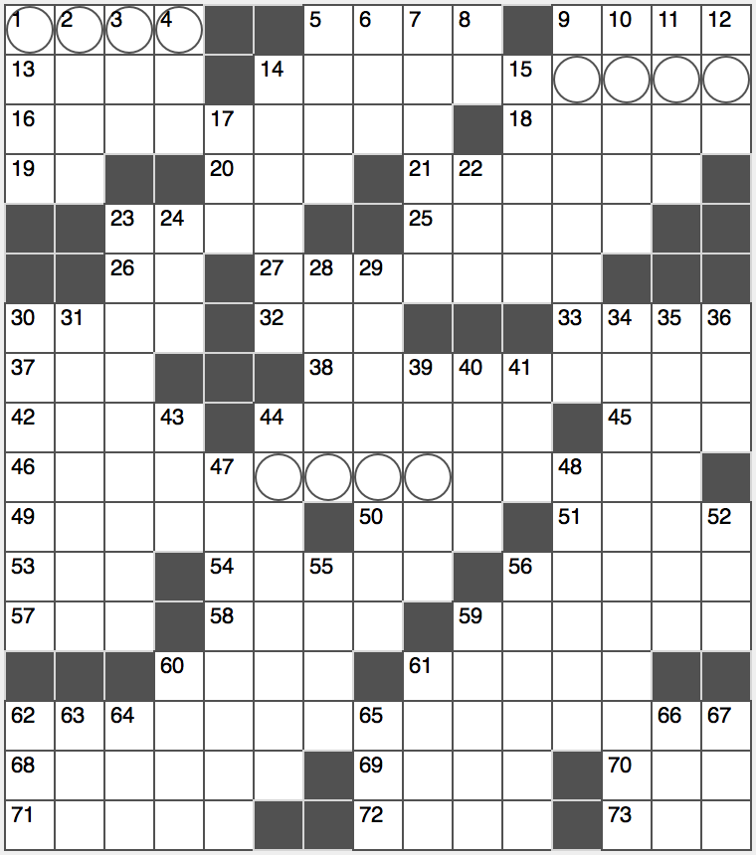**Across**

1. See 9-Across

5. See 9-Across

9. With 1- and 5-Across, Harry Potter character described as loony and an oddity

13. “How now! _______?” (*Hamlet*: Act 3, Scene 4)

14. Odd-toed ungulate

16. Far from relaxed

18. Shield of Zeus

19. 11th of 50, abbr.

20. It may be measured on a doorframe, abbr.

21. Deeply engrained

23. Fellow

25. Valleys

26. Little Rock’s state, abbr.

27. Flew the coop

30. Like a fire or flood, abbr.

32. Contents of a La Brea pit

33. Daily afternoon Islam prayers

37. Many a roadside bomb

38. Keepsakes, var.

42. Old Pontiacs

44. Opening word

45. Passing stat.

46. Nixon and Ford Secretary of State

49. Laddish girl

50. List limiting letters

51. The Netherlands Space Office and the National Solar Observatory, for example

53. Charlemagne’s domain

54. Onsets of invasions

56. Sum

57. Draft org.

58. Emerald Isle

59. Tragedy’s go-with

60. Middle name of “The Wizard of Menlo Park”

61. Ending for “sea” or “way”

62. Festival originally dedicated to Faunus, the Roman god of agriculture, hints to which are contained in the circled squares

68. College visitor, e.g.

69. Chief Norse god

70. Exist

71. Certain Russian space rocket

72. Almost all (of)

73. Opposite of yang

**Down**

1. This skull has ____ in the earth (*Hamlet*: Act 5, Scene 1)
2. Paris airport
3. Swarthmore president, familiarly
4. Cockpit estimate, for short
5. Name of two Indian mountain ranges
6. Some Yiddish interjections
7. Empire State lake near Utica
8. Afro, e.g.
9. Gazed maliciously
10. Impulses
11. Solenoid terminus?
12. Stubborn animal

14. Wish undone

15. Antenna alternative

17. Feature of “the English language”?

22. Siesta

23. Relatives of “no you first”s and “Excusez-moi”s

24. Work bit

28. “We are not the _____ am a martian” (*Phone Home*, Lil Wayne)

29. Strabismus

30. Pizza partitions

31. Shooting stars

34. Dated

35. Right path of life in Native American culture

36. Snake sound

39. A schooner has two

40. Feature of pandemics and epidemics?

41. Bed linen end?

43. Where one might spend a dinar for dinner, abbr.

44. Plummeting professional

47. Swiss singer, maybe

48. Garden figures

52. Like some winks and grins

55. Irish knitwear style

56. Available, as housing

59. Coyote’s genus

60. Old-timers assoc.

61. Alternative to Spot or Rover

62. E.S.T. component, abbr.

63. Lot

64. View, at Versailles

65. Daisy’s husband in *The Great Gatsby*

66. Onassis, to Jackie

67. Longing